COGNIZANT

Digital Nurture 4.0

Deep Skilling - Java FSE

WEEK-4 HANDS ON

By Kaviya P

2.SPRING-REST -HANDSON

**HTTP Request Response** 

**HTTP Request – Anatomy**

**Example:**

makefile

Copy code

GET /hello.txt HTTP/1.1

User-Agent: curl/7.16.3 libcurl/7.16.3 OpenSSL/0.9.7l zlib/1.2.3

Host: www.example.com

Accept-Language: en, mi

**Line-by-Line Breakdown:**

| **Line** | **Component** | **Description** |
| --- | --- | --- |
| 1 | GET /hello.txt HTTP/1.1 | **Method**: GET  **Resource**: /hello.txt  **HTTP Version**: 1.1 |
| 2 | User-Agent: ... | Identifies the client (browser, curl, etc.) |
| 3 | Host: www.example.com | Tells the server the hostname being requested (important for virtual hosting) |
| 4 | Accept-Language: en, mi | Languages accepted by the client |

**Note:** The **full URL** in a browser (https://www.example.com/hello.txt) is broken into:

* Host: www.example.com
* Path/Resource: /hello.txt

**HTTP Response – Anatomy**

**Example:**

HTTP/1.1 200 OK

Date: Mon, 27 Jul 2009 12:28:53 GMT

Server: Apache

Last-Modified: Wed, 22 Jul 2009 19:15:56 GMT

ETag: "34aa387-d-1568eb00"

Accept-Ranges: bytes

Content-Length: 51

Vary: Accept-Encoding

Content-Type: text/plain

Hello World! My payload includes a trailing CRLF.

**Hello World RESTful Web Service**

**Method:** GET  
**URL:** /hello  
**Controller:** com.cognizant.spring-learn.controller.HelloController  
**Method Signature:** public String sayHello()  
**Method Implementation:** return hard coded string "Hello World!!"  
**Sample Request**: http://localhost:8083/hello  
**Sample Response:** Hello World!!

**SpringBootApplication.java**

**package** com.cognizant.spring_learn;

**import** org.springframework.boot.SpringApplication;

**import** org.springframework.boot.autoconfigure.SpringBootApplication;

@SpringBootApplication

**public** **class** SpringLearnApplication {

**public** **static** **void** main(String[] args) {

SpringApplication.*run*(SpringLearnApplication.**class**, args);

}

}

**HelloController.java**

**package** com.cognizant.spring_learn.controller;

**import** org.slf4j.Logger;

**import** org.slf4j.LoggerFactory;

**import** org.springframework.web.bind.annotation.GetMapping;

**import** org.springframework.web.bind.annotation.RestController;

@RestController

**public** **class** HelloController {

**private** **static** **final** Logger ***LOGGER*** = LoggerFactory.*getLogger*(HelloController.**class**);

@GetMapping("/hello")

**public** String sayHello() {

***LOGGER***.info("START");

***LOGGER***.info("END");

**return** "Hello World!!";

}

}

**OUTPUT**

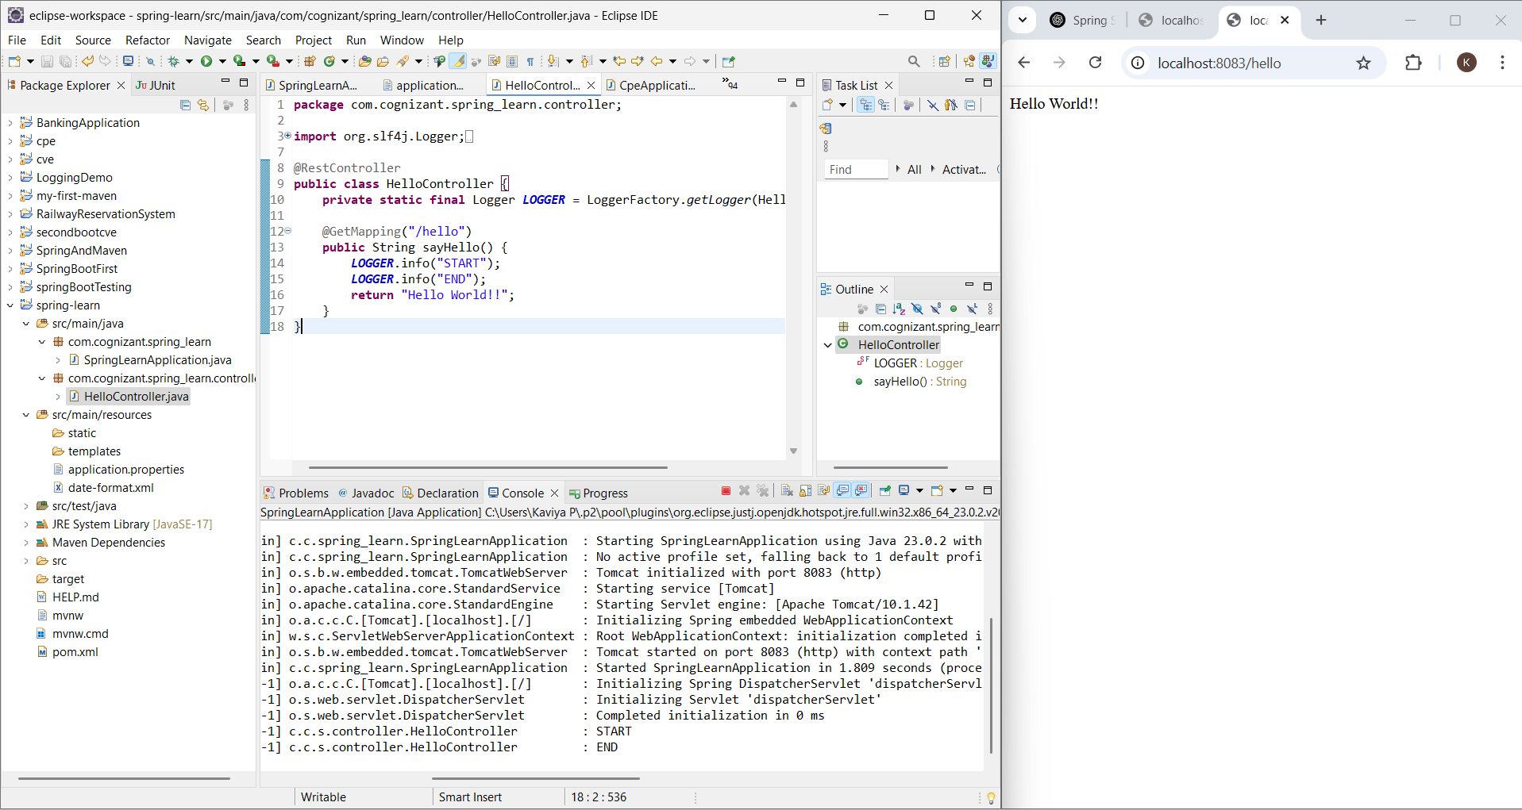

**REST - Country Web Service**

**SpringLearnApplication.java**

**package** com.cognizant.spring_learn;

**import** org.springframework.boot.SpringApplication;

**import** org.springframework.boot.autoconfigure.SpringBootApplication;

@SpringBootApplication

**public** **class** SpringLearnApplication {

**public** **static** **void** main(String[] args) {

SpringApplication.*run*(SpringLearnApplication.**class**, args);

}

}

**CountryController.java**

**package** com.cognizant.spring_learn.controller;

**import** org.slf4j.Logger;

**import** org.slf4j.LoggerFactory;

**import** org.springframework.context.ApplicationContext;

**import** org.springframework.context.support.ClassPathXmlApplicationContext;

**import** org.springframework.web.bind.annotation.RequestMapping;

**import** org.springframework.web.bind.annotation.RestController;

**import** com.cognizant.spring_learn.model.Country;

@RestController

**public** **class** CountryController {

**private** **static** **final** Logger ***LOGGER*** = LoggerFactory.*getLogger*(CountryController.**class**);

@RequestMapping("/country")

**public** Country getCountryIndia() {

***LOGGER***.info("START");

ApplicationContext context = **new** ClassPathXmlApplicationContext("country.xml");

Country country = context.getBean("country", Country.**class**);

***LOGGER***.debug("Country: {}", country);

***LOGGER***.info("END");

**return** country;

}

}

**Country.java**

**package** com.cognizant.spring_learn.model;

**public** **class** Country {

**private** String code;

**private** String name;

**public** Country() {}

**public** String getCode() {

**return** code;

}

**public** **void** setCode(String code) {

**this**.code = code;

}

**public** String getName() {

**return** name;

}

**public** **void** setName(String name) {

**this**.name = name;

}

@Override

**public** String toString() {

**return** "Country [code=" + code + ", name=" + name + "]";

}

}

**country.xml**

<?xml version="1.0" encoding="UTF-8"?>

<beans xmlns="http://www.springframework.org/schema/beans"

xmlns:xsi="http://www.w3.org/2001/XMLSchema-instance"

xsi:schemaLocation="http://www.springframework.org/schema/beans

https://www.springframework.org/schema/beans/spring-beans.xsd">

<bean id="country" class="com.cognizant.spring_learn.model.Country">

<property name="code" value="IN" />

<property name="name" value="India" />

</bean>

</beans>

**OUTPUT**

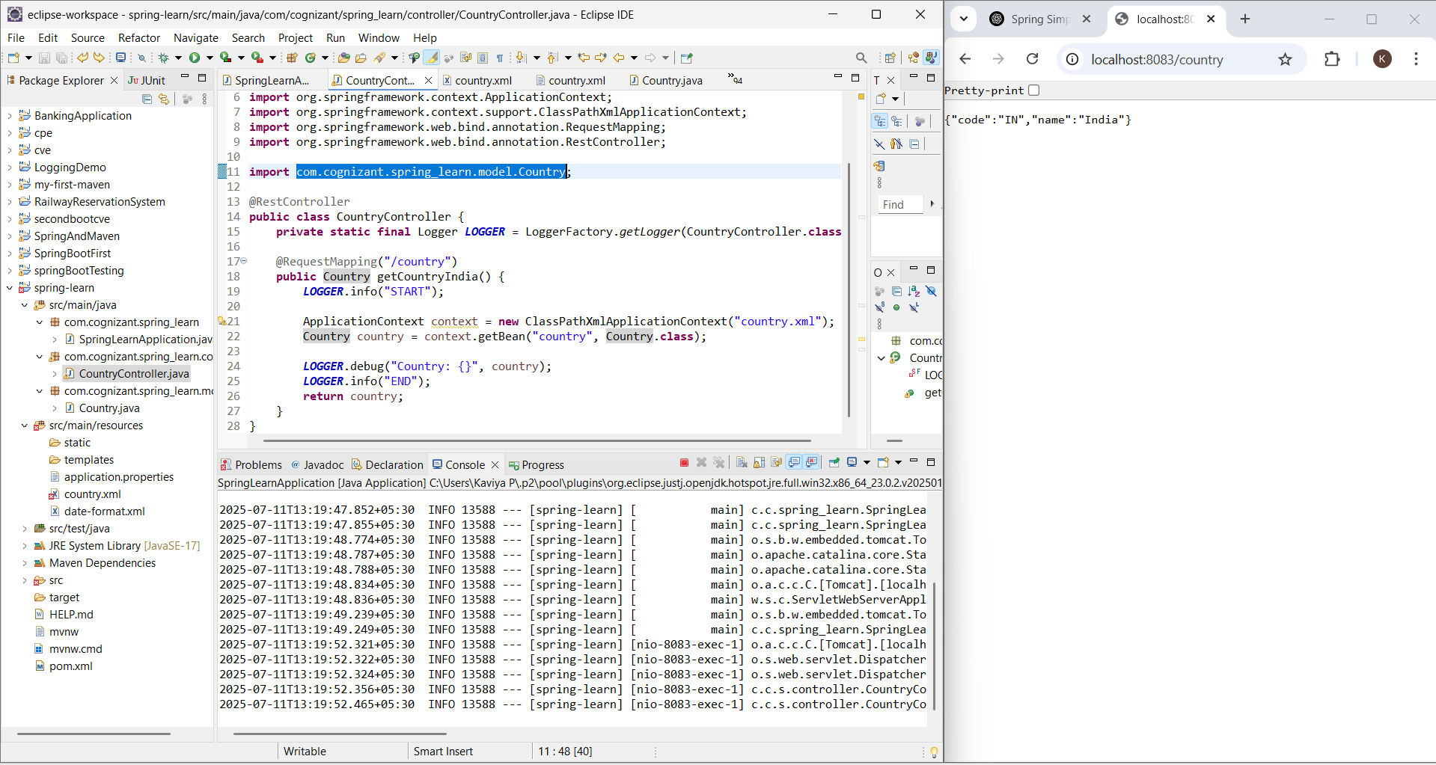

**REST - Get all countries**

**SpringLearnApplication.java  
package** com.cognizant.spring_learn;

**import** org.springframework.boot.SpringApplication;

**import** org.springframework.boot.autoconfigure.SpringBootApplication;

@SpringBootApplication

**public** **class** SpringLearnApplication {

**public** **static** **void** main(String[] args) {

SpringApplication.*run*(SpringLearnApplication.**class**, args);

}

}

**CountryController.java**

**package** com.cognizant.spring_learn.controller;

**import** java.util.List;

**import** org.slf4j.Logger;

**import** org.slf4j.LoggerFactory;

**import** org.springframework.context.ApplicationContext;

**import** org.springframework.context.support.ClassPathXmlApplicationContext;

**import** org.springframework.web.bind.annotation.GetMapping;

**import** org.springframework.web.bind.annotation.RequestMapping;

**import** org.springframework.web.bind.annotation.RestController;

**import** com.cognizant.spring_learn.model.Country;

@RestController

**public** **class** CountryController {

**private** **static** **final** Logger ***LOGGER*** = LoggerFactory.*getLogger*(CountryController.**class**);

@RequestMapping("/country")

**public** Country getCountryIndia() {

***LOGGER***.info("START - getCountryIndia");

ApplicationContext context = **new** ClassPathXmlApplicationContext("country.xml");

Country country = context.getBean("country", Country.**class**);

***LOGGER***.info("END - getCountryIndia");

**return** country;

}

@GetMapping("/countries")

**public** List<Country> getAllCountries() {

***LOGGER***.info("START - getAllCountries");

ApplicationContext context = **new** ClassPathXmlApplicationContext("country.xml");

@SuppressWarnings("unchecked")

List<Country> countries = (List<Country>) context.getBean("countryList");

***LOGGER***.info("END - getAllCountries");

**return** countries;

}

}

**Country.java**

**package** com.cognizant.spring_learn.model;

**public** **class** Country {

**private** String code;

**private** String name;

**public** Country() {}

**public** String getCode() {

**return** code;

}

**public** **void** setCode(String code) {

**this**.code = code;

}

**public** String getName() {

**return** name;

}

**public** **void** setName(String name) {

**this**.name = name;

}

@Override

**public** String toString() {

**return** "Country [code=" + code + ", name=" + name + "]";

}

}

**Country.xml**<?xml version="1.0" encoding="UTF-8"?>

<beans xmlns="http://www.springframework.org/schema/beans"

xmlns:xsi="http://www.w3.org/2001/XMLSchema-instance"

xsi:schemaLocation="http://www.springframework.org/schema/beans

https://www.springframework.org/schema/beans/spring-beans.xsd">

<bean id="in" class="com.cognizant.spring_learn.model.Country">

<property name="code" value="IN" />

<property name="name" value="India" />

</bean>

<bean id="us" class="com.cognizant.spring_learn.model.Country">

<property name="code" value="US" />

<property name="name" value="United States" />

</bean>

<bean id="jp" class="com.cognizant.spring_learn.model.Country">

<property name="code" value="JP" />

<property name="name" value="Japan" />

</bean>

<bean id="de" class="com.cognizant.spring_learn.model.Country">

<property name="code" value="DE" />

<property name="name" value="Germany" />

</bean>

<bean id="countryList" class="java.util.ArrayList">

<constructor-arg>

<list>

<ref bean="in" />

<ref bean="us" />

<ref bean="jp" />

<ref bean="de" />

</list>

</constructor-arg>

</bean>

</beans>

**OUTPUT**

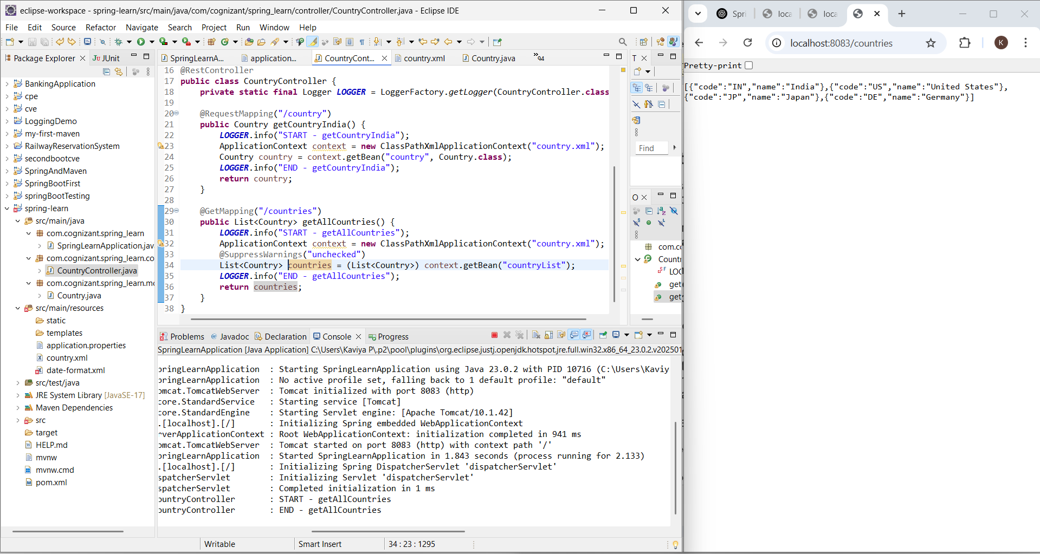

**REST - Get country based on country code**   
  
**SpringLearnApplication.java  
package** com.cognizant.spring_learn;

**import** org.springframework.boot.SpringApplication;

**import** org.springframework.boot.autoconfigure.SpringBootApplication;

@SpringBootApplication

**public** **class** SpringLearnApplication {

**public** **static** **void** main(String[] args) {

SpringApplication.*run*(SpringLearnApplication.**class**, args);

}

}

**Country.java**

**package** com.cognizant.spring_learn.model;

**public** **class** Country {

**private** String code;

**private** String name;

**public** Country() {}

**public** String getCode() {

**return** code;

}

**public** **void** setCode(String code) {

**this**.code = code;

}

**public** String getName() {

**return** name;

}

**public** **void** setName(String name) {

**this**.name = name;

}

@Override

**public** String toString() {

**return** "Country [code=" + code + ", name=" + name + "]";

}

}

**CountryController.java**

**package** com.cognizant.spring_learn.controller;

**import** java.util.List;

**import** org.slf4j.Logger;

**import** org.slf4j.LoggerFactory;

**import** org.springframework.beans.factory.annotation.Autowired;

**import** org.springframework.context.ApplicationContext;

**import** org.springframework.context.support.ClassPathXmlApplicationContext;

**import** org.springframework.web.bind.annotation.GetMapping;

**import** org.springframework.web.bind.annotation.PathVariable;

**import** org.springframework.web.bind.annotation.RequestMapping;

**import** org.springframework.web.bind.annotation.RestController;

**import** com.cognizant.spring_learn.model.Country;

**import** com.cognizant.spring_learn.service.CountryService;

@RestController

**public** **class** CountryController {

**private** **static** **final** Logger ***LOGGER*** = LoggerFactory.*getLogger*(CountryController.**class**);

@Autowired

**private** CountryService countryService;

@GetMapping("/countries/{code}")

**public** Country getCountry(@PathVariable String code) {

***LOGGER***.info("START - getCountry()");

Country country = countryService.getCountry(code);

***LOGGER***.info("END - getCountry()");

**return** country;

}

}

**CountryService.java**

**package** com.cognizant.spring_learn.service;

**import** java.util.List;

**import** java.util.Optional;

**import** org.springframework.context.ApplicationContext;

**import** org.springframework.context.support.ClassPathXmlApplicationContext;

**import** org.springframework.stereotype.Service;

**import** com.cognizant.spring_learn.model.Country;

@Service

**public** **class** CountryService {

**public** Country getCountry(String code) {

ApplicationContext context = **new** ClassPathXmlApplicationContext("country.xml");

List<Country> countryList = (List<Country>) context.getBean("countryList");

Optional<Country> matchedCountry = countryList.stream()

.filter(c -> c.getCode().equalsIgnoreCase(code))

.findFirst();

**return** matchedCountry.orElse(**null**); // or throw a custom exception if not found

}

}

**Country.xml**

<?xml version="1.0" encoding="UTF-8"?>

<beans xmlns="http://www.springframework.org/schema/beans"

xmlns:xsi="http://www.w3.org/2001/XMLSchema-instance"

xsi:schemaLocation="http://www.springframework.org/schema/beans

https://www.springframework.org/schema/beans/spring-beans.xsd">

<bean id="in" class="com.cognizant.spring_learn.model.Country">

<property name="code" value="IN" />

<property name="name" value="India" />

</bean>

<bean id="us" class="com.cognizant.spring_learn.model.Country">

<property name="code" value="US" />

<property name="name" value="United States" />

</bean>

<bean id="jp" class="com.cognizant.spring_learn.model.Country">

<property name="code" value="JP" />

<property name="name" value="Japan" />

</bean>

<bean id="de" class="com.cognizant.spring_learn.model.Country">

<property name="code" value="DE" />

<property name="name" value="Germany" />

</bean>

<bean id="countryList" class="java.util.ArrayList">

<constructor-arg>

<list>

<ref bean="in"/>

<ref bean="us"/>

<ref bean="jp"/>

<ref bean="de"/>

</list>

</constructor-arg>

</bean>

</beans>

**OUTPUT**

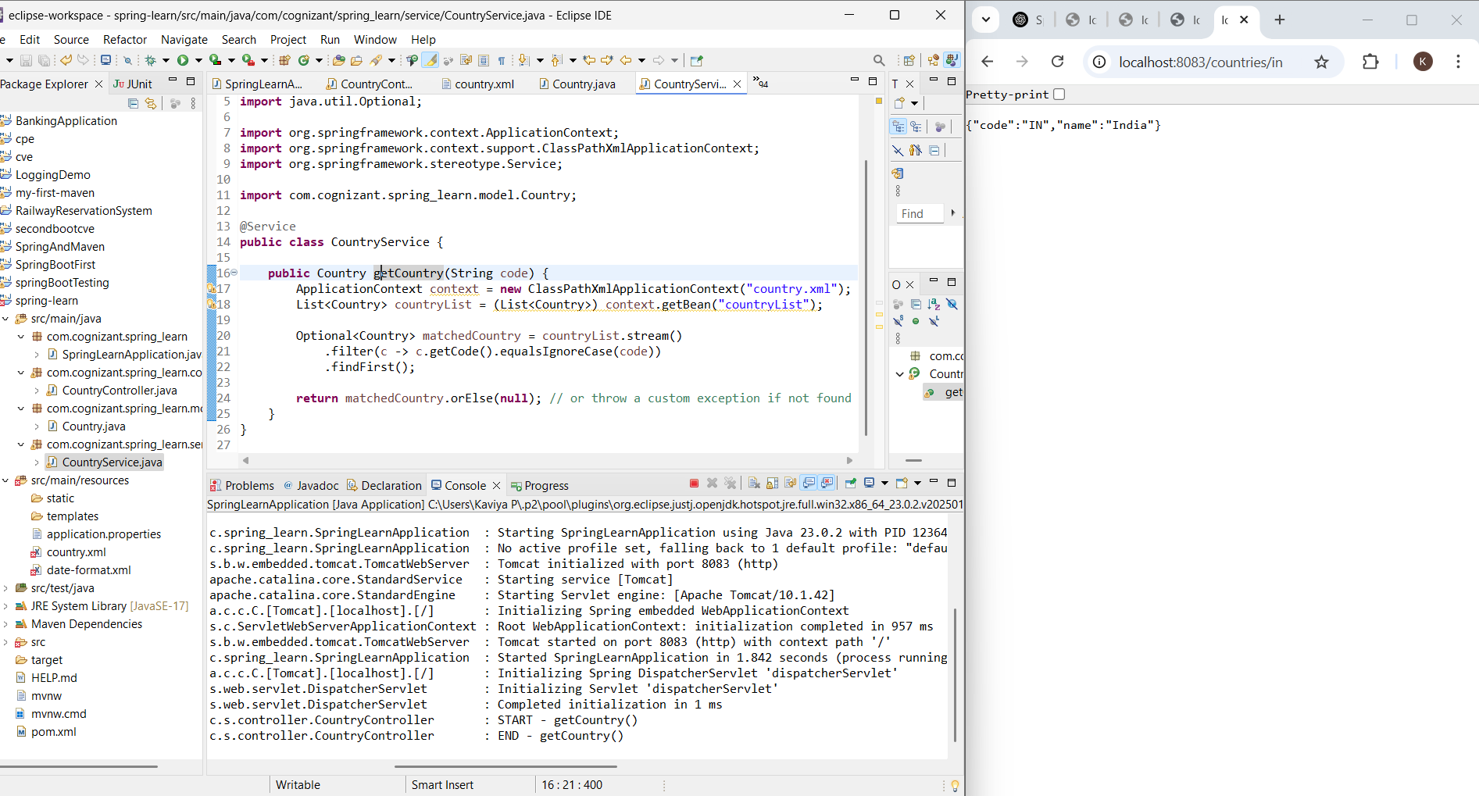

**REST - Get country exceptional scenario**

**SpringLearnApplication.java  
package** com.cognizant.spring_learn;

**import** org.springframework.boot.SpringApplication;

**import** org.springframework.boot.autoconfigure.SpringBootApplication;

@SpringBootApplication

**public** **class** SpringLearnApplication {

**public** **static** **void** main(String[] args) {

SpringApplication.*run*(SpringLearnApplication.**class**, args);

}

}

**Country.java**

**package** com.cognizant.spring_learn.model;

**public** **class** Country {

**private** String code;

**private** String name;

**public** Country() {}

**public** String getCode() {

**return** code;

}

**public** **void** setCode(String code) {

**this**.code = code;

}

**public** String getName() {

**return** name;

}

**public** **void** setName(String name) {

**this**.name = name;

}

@Override

**public** String toString() {

**return** "Country [code=" + code + ", name=" + name + "]";

}

}

**CountryController.java**

**package** com.cognizant.spring_learn.controller;

**import** java.util.List;

**import** org.slf4j.Logger;

**import** org.slf4j.LoggerFactory;

**import** org.springframework.beans.factory.annotation.Autowired;

**import** org.springframework.context.ApplicationContext;

**import** org.springframework.context.support.ClassPathXmlApplicationContext;

**import** org.springframework.web.bind.annotation.GetMapping;

**import** org.springframework.web.bind.annotation.PathVariable;

**import** org.springframework.web.bind.annotation.RequestMapping;

**import** org.springframework.web.bind.annotation.RestController;

**import** com.cognizant.spring_learn.model.Country;

**import** com.cognizant.spring_learn.service.CountryNotFoundException;

**import** com.cognizant.spring_learn.service.CountryService;

@RestController

**public** **class** CountryController {

**private** **static** **final** Logger ***LOGGER*** = LoggerFactory.*getLogger*(CountryController.**class**);

@Autowired

**private** CountryService countryService;

@GetMapping("/countries/{code}")

**public** Country getCountry(@PathVariable String code) **throws** CountryNotFoundException {

***LOGGER***.info("START - getCountry()");

Country country = countryService.getCountry(code);

***LOGGER***.info("END - getCountry()");

**return** country;

}

}

**CountryService.java**

**package** com.cognizant.spring_learn.service;

**import** java.util.List;

**import** java.util.Optional;

**import** org.springframework.context.ApplicationContext;

**import** org.springframework.context.support.ClassPathXmlApplicationContext;

**import** org.springframework.stereotype.Service;

**import** com.cognizant.spring_learn.model.Country;

@Service

**public** **class** CountryService {

**public** Country getCountry(String code) **throws** CountryNotFoundException {

ApplicationContext context = **new** ClassPathXmlApplicationContext("country.xml");

List<Country> countryList = (List<Country>) context.getBean("countryList");

Optional<Country> matchedCountry = countryList.stream()

.filter(c -> c.getCode().equalsIgnoreCase(code))

.findFirst();

**if** (matchedCountry.isEmpty()) {

**throw** **new** CountryNotFoundException("Country not found");

}

**return** matchedCountry.get();

}

}

**CountryNotFoundException.java**

**package** com.cognizant.spring_learn.service;

**import** org.springframework.http.HttpStatus;

**import** org.springframework.web.bind.annotation.ResponseStatus;

@ResponseStatus(value = HttpStatus.***NOT_FOUND***, reason = "Country not found")

**public** **class** CountryNotFoundException **extends** Exception {

**public** CountryNotFoundException(String message) {

**super**(message);

}

}

**Country.xml**

<?xml version="1.0" encoding="UTF-8"?>

<beans xmlns="http://www.springframework.org/schema/beans"

xmlns:xsi="http://www.w3.org/2001/XMLSchema-instance"

xsi:schemaLocation="http://www.springframework.org/schema/beans

https://www.springframework.org/schema/beans/spring-beans.xsd">

<bean id="in" class="com.cognizant.spring_learn.model.Country">

<property name="code" value="IN" />

<property name="name" value="India" />

</bean>

<bean id="us" class="com.cognizant.spring_learn.model.Country">

<property name="code" value="US" />

<property name="name" value="United States" />

</bean>

<bean id="jp" class="com.cognizant.spring_learn.model.Country">

<property name="code" value="JP" />

<property name="name" value="Japan" />

</bean>

<bean id="de" class="com.cognizant.spring_learn.model.Country">

<property name="code" value="DE" />

<property name="name" value="Germany" />

</bean>

<bean id="countryList" class="java.util.ArrayList">

<constructor-arg>

<list>

<ref bean="in"/>

<ref bean="us"/>

<ref bean="jp"/>

<ref bean="de"/>

</list>

</constructor-arg>

</bean>

</beans>

**OUTPUT**

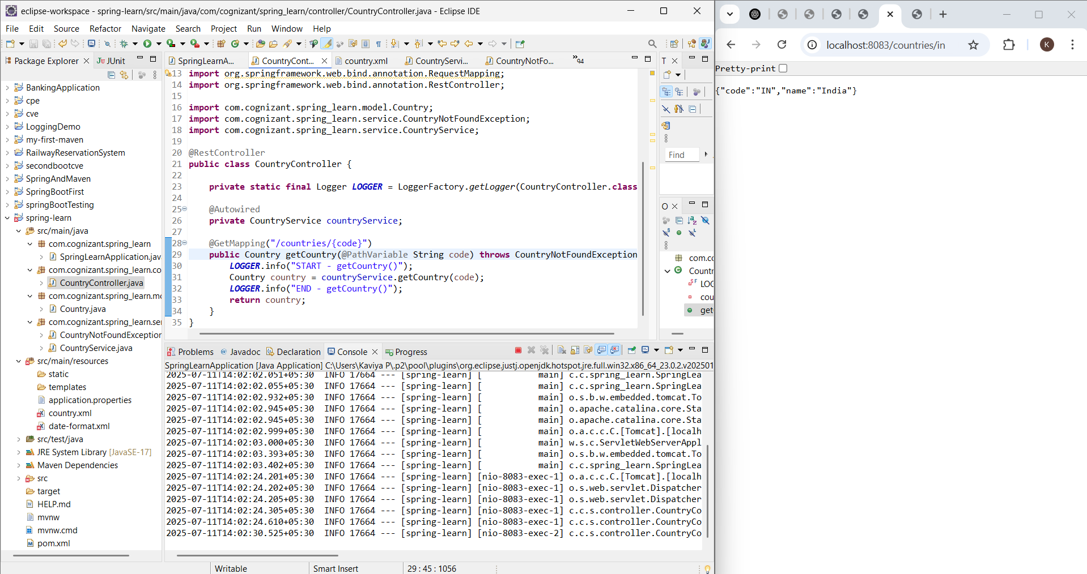

**MockMVC - Test get country service** 

**SpringLearnApplication.java  
package** com.cognizant.spring_learn;

**import** org.springframework.boot.SpringApplication;

**import** org.springframework.boot.autoconfigure.SpringBootApplication;

@SpringBootApplication

**public** **class** SpringLearnApplication {

**public** **static** **void** main(String[] args) {

SpringApplication.*run*(SpringLearnApplication.**class**, args);

}

}

**Country.java**

**package** com.cognizant.spring_learn.model;

**public** **class** Country {

**private** String code;

**private** String name;

**public** Country() {}

**public** String getCode() {

**return** code;

}

**public** **void** setCode(String code) {

**this**.code = code;

}

**public** String getName() {

**return** name;

}

**public** **void** setName(String name) {

**this**.name = name;

}

@Override

**public** String toString() {

**return** "Country [code=" + code + ", name=" + name + "]";

}

}

**CountryController.java**

**package** com.cognizant.spring_learn.controller;

**import** java.util.List;

**import** org.slf4j.Logger;

**import** org.slf4j.LoggerFactory;

**import** org.springframework.beans.factory.annotation.Autowired;

**import** org.springframework.context.ApplicationContext;

**import** org.springframework.context.support.ClassPathXmlApplicationContext;

**import** org.springframework.web.bind.annotation.GetMapping;

**import** org.springframework.web.bind.annotation.PathVariable;

**import** org.springframework.web.bind.annotation.RequestMapping;

**import** org.springframework.web.bind.annotation.RestController;

**import** com.cognizant.spring_learn.model.Country;

**import** com.cognizant.spring_learn.service.CountryNotFoundException;

**import** com.cognizant.spring_learn.service.CountryService;

@RestController

**public** **class** CountryController {

**private** **static** **final** Logger ***LOGGER*** = LoggerFactory.*getLogger*(CountryController.**class**);

@Autowired

**private** CountryService countryService;

@GetMapping("/country")

**public** Country getCountryIndia() {

***LOGGER***.info("START - getCountryIndia()");

ApplicationContext context = **new** ClassPathXmlApplicationContext("country.xml");

Country country = context.getBean("in", Country.**class**);

***LOGGER***.info("END - getCountryIndia()");

**return** country;

}

}

**CountryService.java**

**package** com.cognizant.spring_learn.service;

**import** java.util.List;

**import** java.util.Optional;

**import** org.springframework.context.ApplicationContext;

**import** org.springframework.context.support.ClassPathXmlApplicationContext;

**import** org.springframework.stereotype.Service;

**import** com.cognizant.spring_learn.model.Country;

@Service

**public** **class** CountryService {

**public** Country getCountry(String code) **throws** CountryNotFoundException {

ApplicationContext context = **new** ClassPathXmlApplicationContext("country.xml");

List<Country> countryList = (List<Country>) context.getBean("countryList");

Optional<Country> matchedCountry = countryList.stream()

.filter(c -> c.getCode().equalsIgnoreCase(code))

.findFirst();

**if** (matchedCountry.isEmpty()) {

**throw** **new** CountryNotFoundException("Country not found");

}

**return** matchedCountry.get();

}

}

**SpringLearnApplicationTests.java**

**package** com.cognizant.spring_learn;

**import** **static** org.junit.jupiter.api.Assertions.*assertNotNull*;

**import** **static** org.springframework.test.web.servlet.request.MockMvcRequestBuilders.*get*;

**import** **static** org.springframework.test.web.servlet.result.MockMvcResultMatchers.*;

**import** com.cognizant.spring_learn.controller.CountryController;

**import** org.junit.jupiter.api.Test;

**import** org.springframework.beans.factory.annotation.Autowired;

**import** org.springframework.boot.test.autoconfigure.web.servlet.AutoConfigureMockMvc;

**import** org.springframework.boot.test.context.SpringBootTest;

**import** org.springframework.test.web.servlet.MockMvc;

**import** org.springframework.test.web.servlet.ResultActions;

@SpringBootTest

@AutoConfigureMockMvc

**public** **class** SpringLearnApplicationTests {

@Autowired

**private** CountryController countryController;

@Autowired

**private** MockMvc mvc;

@Test

**public** **void** contextLoads() {

*assertNotNull*(countryController);

}

@Test

**public** **void** testGetCountry() **throws** Exception {

ResultActions actions = mvc.perform(*get*("/country"));

actions.andExpect(*status*().isOk());

actions.andExpect(*jsonPath*("$.code").exists());

actions.andExpect(*jsonPath*("$.code").value("IN"));

actions.andExpect(*jsonPath*("$.name").exists());

actions.andExpect(*jsonPath*("$.name").value("India"));

}

}

**CountryNotFoundException.java**

**package** com.cognizant.spring_learn.service;

**import** org.springframework.http.HttpStatus;

**import** org.springframework.web.bind.annotation.ResponseStatus;

@ResponseStatus(value = HttpStatus.***NOT_FOUND***, reason = "Country not found")

**public** **class** CountryNotFoundException **extends** Exception {

**public** CountryNotFoundException(String message) {

**super**(message);

}

}

**Country.xml**

<?xml version="1.0" encoding="UTF-8"?>

<beans xmlns="http://www.springframework.org/schema/beans"

xmlns:xsi="http://www.w3.org/2001/XMLSchema-instance"

xsi:schemaLocation="http://www.springframework.org/schema/beans

https://www.springframework.org/schema/beans/spring-beans.xsd">

<bean id="in" class="com.cognizant.spring_learn.model.Country">

<property name="code" value="IN" />

<property name="name" value="India" />

</bean>

<bean id="us" class="com.cognizant.spring_learn.model.Country">

<property name="code" value="US" />

<property name="name" value="United States" />

</bean>

<bean id="jp" class="com.cognizant.spring_learn.model.Country">

<property name="code" value="JP" />

<property name="name" value="Japan" />

</bean>

<bean id="de" class="com.cognizant.spring_learn.model.Country">

<property name="code" value="DE" />

<property name="name" value="Germany" />

</bean>

<bean id="countryList" class="java.util.ArrayList">

<constructor-arg>

<list>

<ref bean="in"/>

<ref bean="us"/>

<ref bean="jp"/>

<ref bean="de"/>

</list>

</constructor-arg>

</bean>

</beans>

**OUTPUT**

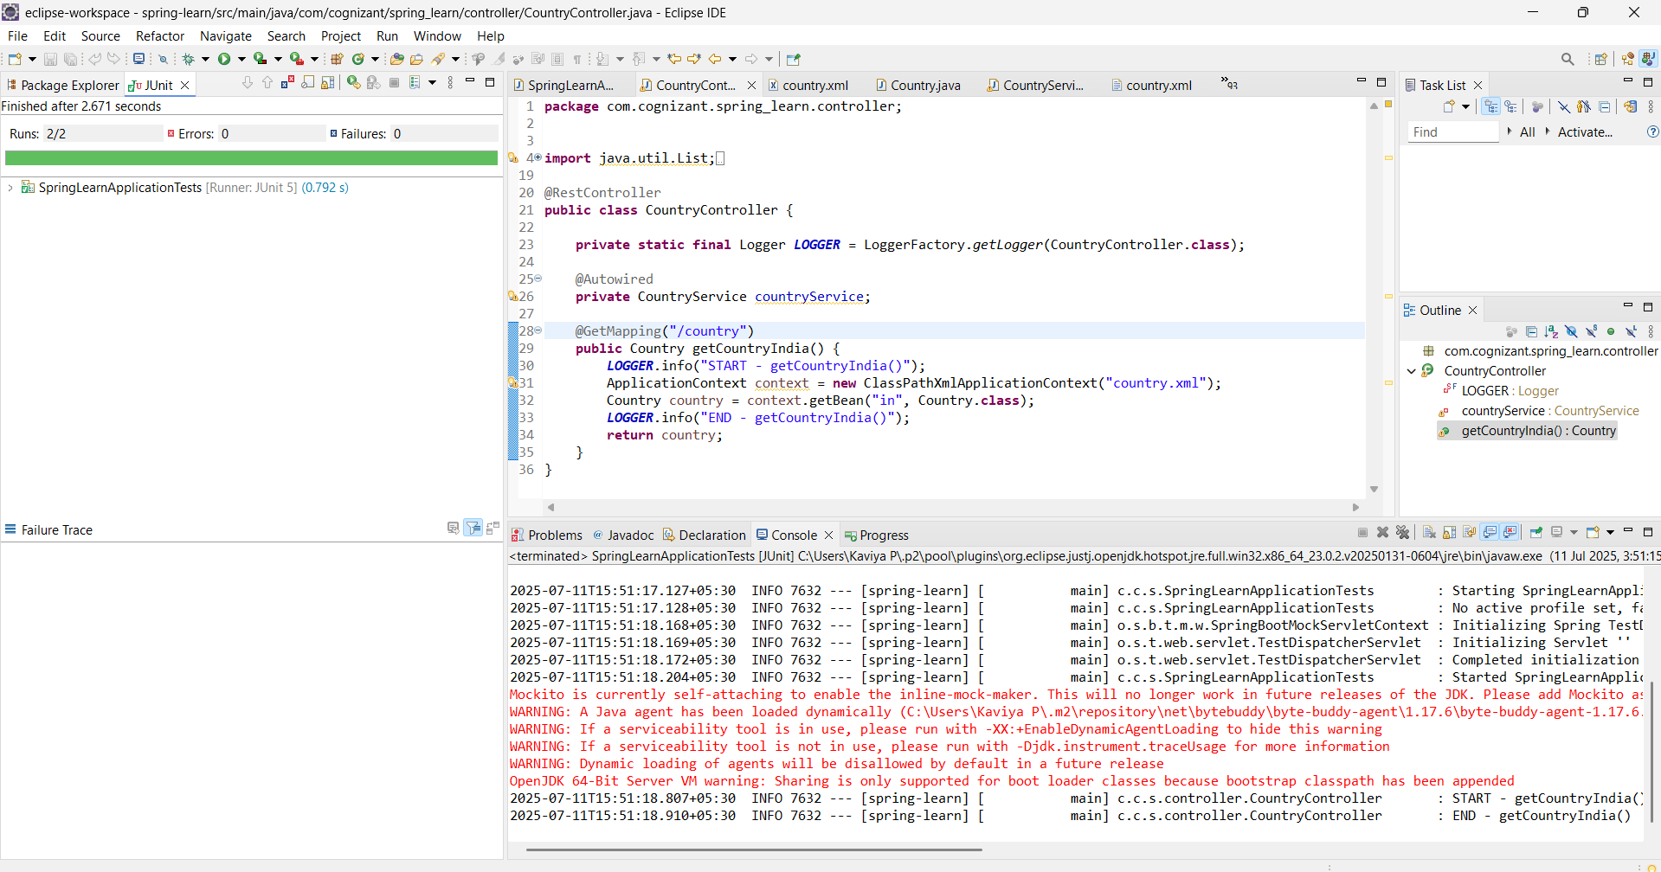

**MockMVC - Test get country service for exceptional scenario**

**SpringLearnApplication.java  
package** com.cognizant.spring_learn;

**import** org.springframework.boot.SpringApplication;

**import** org.springframework.boot.autoconfigure.SpringBootApplication;

@SpringBootApplication

**public** **class** SpringLearnApplication {

**public** **static** **void** main(String[] args) {

SpringApplication.*run*(SpringLearnApplication.**class**, args);

}

}

**Country.java**

**package** com.cognizant.spring_learn.model;

**public** **class** Country {

**private** String code;

**private** String name;

**public** Country() {}

**public** String getCode() {

**return** code;

}

**public** **void** setCode(String code) {

**this**.code = code;

}

**public** String getName() {

**return** name;

}

**public** **void** setName(String name) {

**this**.name = name;

}

@Override

**public** String toString() {

**return** "Country [code=" + code + ", name=" + name + "]";

}

}

**CountryController.java**

**package** com.cognizant.spring_learn.controller;

**import** java.util.List;

**import** org.slf4j.Logger;

**import** org.slf4j.LoggerFactory;

**import** org.springframework.beans.factory.annotation.Autowired;

**import** org.springframework.context.ApplicationContext;

**import** org.springframework.context.support.ClassPathXmlApplicationContext;

**import** org.springframework.web.bind.annotation.GetMapping;

**import** org.springframework.web.bind.annotation.PathVariable;

**import** org.springframework.web.bind.annotation.RequestMapping;

**import** org.springframework.web.bind.annotation.RestController;

**import** com.cognizant.spring_learn.model.Country;

**import** com.cognizant.spring_learn.service.CountryNotFoundException;

**import** com.cognizant.spring_learn.service.CountryService;

@RestController

**public** **class** CountryController {

**private** **static** **final** Logger ***LOGGER*** = LoggerFactory.*getLogger*(CountryController.**class**);

@Autowired

**private** CountryService countryService;

@GetMapping("/country")

**public** Country getCountryIndia() {

***LOGGER***.info("START - getCountryIndia()");

ApplicationContext context = **new** ClassPathXmlApplicationContext("country.xml");

Country country = context.getBean("in", Country.**class**);

***LOGGER***.info("END - getCountryIndia()");

**return** country;

}

}

**CountryService.java**

**package** com.cognizant.spring_learn.service;

**import** java.util.List;

**import** java.util.Optional;

**import** org.springframework.context.ApplicationContext;

**import** org.springframework.context.support.ClassPathXmlApplicationContext;

**import** org.springframework.stereotype.Service;

**import** com.cognizant.spring_learn.model.Country;

@Service

**public** **class** CountryService {

**public** Country getCountry(String code) **throws** CountryNotFoundException {

ApplicationContext context = **new** ClassPathXmlApplicationContext("country.xml");

List<Country> countryList = (List<Country>) context.getBean("countryList");

Optional<Country> matchedCountry = countryList.stream()

.filter(c -> c.getCode().equalsIgnoreCase(code))

.findFirst();

**if** (matchedCountry.isEmpty()) {

**throw** **new** CountryNotFoundException("Country not found");

}

**return** matchedCountry.get();

}

}

**CountryNotFoundException.java**

**package** com.cognizant.spring_learn.service;

**import** org.springframework.http.HttpStatus;

**import** org.springframework.web.bind.annotation.ResponseStatus;

@ResponseStatus(value = HttpStatus.***NOT_FOUND***, reason = "Country not found")

**public** **class** CountryNotFoundException **extends** Exception {

**public** CountryNotFoundException(String message) {

**super**(message);

}

}

**Country.xml**

<?xml version="1.0" encoding="UTF-8"?>

<beans xmlns="http://www.springframework.org/schema/beans"

xmlns:xsi="http://www.w3.org/2001/XMLSchema-instance"

xsi:schemaLocation="http://www.springframework.org/schema/beans

https://www.springframework.org/schema/beans/spring-beans.xsd">

<bean id="in" class="com.cognizant.spring_learn.model.Country">

<property name="code" value="IN" />

<property name="name" value="India" />

</bean>

<bean id="us" class="com.cognizant.spring_learn.model.Country">

<property name="code" value="US" />

<property name="name" value="United States" />

</bean>

<bean id="jp" class="com.cognizant.spring_learn.model.Country">

<property name="code" value="JP" />

<property name="name" value="Japan" />

</bean>

<bean id="de" class="com.cognizant.spring_learn.model.Country">

<property name="code" value="DE" />

<property name="name" value="Germany" />

</bean>

<bean id="countryList" class="java.util.ArrayList">

<constructor-arg>

<list>

<ref bean="in"/>

<ref bean="us"/>

<ref bean="jp"/>

<ref bean="de"/>

</list>

</constructor-arg>

</bean>

</beans>

**SpringLearnApplicationTests.java**

**package** com.cognizant.spring_learn;

**import** **static** org.springframework.test.web.servlet.request.MockMvcRequestBuilders.*get*;

**import** **static** org.springframework.test.web.servlet.result.MockMvcResultMatchers.*status*;

**import** **static** org.springframework.test.web.servlet.result.MockMvcResultMatchers.*status*;

**import** **static** org.springframework.test.web.servlet.result.MockMvcResultMatchers.*status*;

**import** **static** org.junit.jupiter.api.Assertions.*assertNotNull*;

**import** com.cognizant.spring_learn.controller.CountryController;

**import** org.junit.jupiter.api.Test;

**import** org.springframework.beans.factory.annotation.Autowired;

**import** org.springframework.boot.test.autoconfigure.web.servlet.AutoConfigureMockMvc;

**import** org.springframework.boot.test.context.SpringBootTest;

**import** org.springframework.test.web.servlet.MockMvc;

**import** org.springframework.test.web.servlet.ResultActions;

@SpringBootTest

@AutoConfigureMockMvc

**public** **class** SpringLearnApplicationTests {

@Autowired

**private** MockMvc mockMvc;

@Autowired

**private** CountryController countryController;

@Test

**public** **void** contextLoads() {

*assertNotNull*(countryController);

}

@Test

**public** **void** testGetCountry() **throws** Exception {

ResultActions actions = mockMvc.perform(*get*("/country"));

actions.andExpect(*status*().isOk());

}

@Test

**public** **void** testGetCountryException() **throws** Exception {

ResultActions actions = mockMvc.perform(*get*("/countries/invalid"));

actions.andExpect(*status*().isNotFound()) // 404 expected

.andExpect(*status*().reason("Country not found"));

}

}

**OUTPUT**

